Project Report

- INTRODUCTION

1.1 PYTHON

What is Python

- Python is a high-level, general-purpose, open source, strictly typed programming language. The language provides constructs intended to enable clear programs on both

a small and large scale.

- Python was Created By Guido van Rossum.

- The Python Software Foundation(PSF) is the organization behind Python.

Python versions
- First released in 1991.

- Python 2.0 was released on 16 October 2000

- Python 3.0 was released on 3 December 2008

- Current Versions:

  - 3.6.3

  - 2.7.14

Python features

Some of the features of python include
- Dynamic

- Object oriented

- Multipurpose

- Strongly typed

- Open Sourced

Python is widely used in many domains

RAUNAK Page 1
Project Report

- Web Development

- Data Analysis

- Machine Learning

- Internet Of Things

- GUI Development

- Image processing

- Data visualization

- Game Development

IDLE

IDLE is an integrated development environment for Python, which has been bundled with the default implementation of the language

1.2 ANACONADA

Anaconda is a open source Distribution for data science and machine learning using python. It includes hundreds of popular data science packages and the conda package and virtual environment manager for Windows, Linux, and MacOS. Conda makes it quick and easy to install, run, and upgrade complex data science and machine learning environments like scikit-learn, TensorFlow, and SciPy. Anaconda Distribution is the foundation of millions of data science projects as well as Amazon Web Services Machine Learning AMIs and Anaconda for Microsoft on Azure and Windows.

RAUNAK Page 2
Project Report

1.3 IPYHTON

Python (Interactive Python) is a command shell for interactive computing in multiple programming languages, originally developed for the Python programming language, that offers introspection, rich media, shell syntax, tab completion, and history. IPython provides the following features:

- Interactive shells (terminal and Qt-based).

- A browser-based notebook interface with support for code, text, mathematical

- expressions, inline plots and other media.

- Support for interactive data visualization and use of GUI toolkits.

- Flexible, embeddable interpreters to load into one's own projects.

- Tools for parallel computing.

1.4 Packages

1.4.1 Numpy

NumPy is the fundamental package for scientific computing with Python. It contains among

other things:

- a powerful N-dimensional array object
- sophisticated (broadcasting) functions
- tools for integrating C/C++ and Fortran code
- useful linear algebra, Fourier transform, and random number capabilities

Besides its obvious scientific uses, NumPy can also be used as an efficient multi-dimensional

container of generic data. Arbitrary data-types can be defined. This allows NumPy to

seamlessly and speedily integrate with a wide variety of databases.

1.4.2 Matplotlib

Matplotlib is a Python 2D plotting library which produces publication quality figures in a

variety of hardcopy formats and interactive environments across platforms. Matplotlib can

be used in Python scripts, the Python and IPython shell, the jupyter notebook, web

application servers, and four graphical user interface toolkits.

RAUNAK Page 3
Project Report
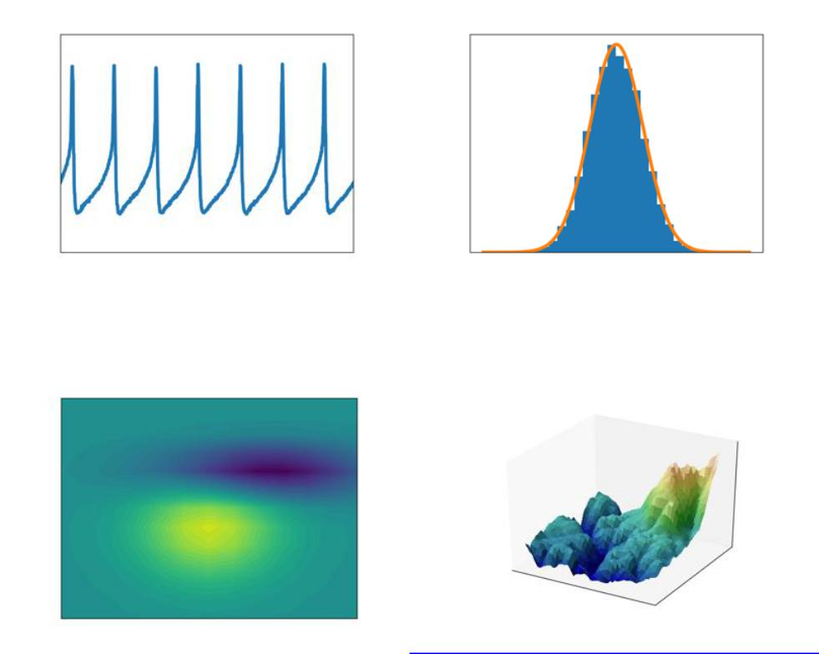

Matplotlib tries to make easy things easy and hard things possible. You can generate plots,

histograms, power spectra, bar charts, errorcharts, scatterplots, etc., with just a few lines of

code.

For simple plotting the pyplot module provides a MATLAB-like interface, particularly when

combined with IPython. For the power user, you have full control of line styles, font

properties, axes properties, etc, via an object oriented interface or via a set of functions

familiar to MATLAB users.

1.4.3 Scikit-learn

Scikit-learn provides machine learning libraries for python some of the features of Scikit-learn includes:

- Simple and efficient tools for data mining and data analysis
- Accessible to everybody, and reusable in various contexts
- Built on NumPy, SciPy, and matplotlib
- Open source, commercially usable - BSD license

RAUNAK Page 4
Project Report

1.4.4 Pandas

Pandas is an open source, BSD-licensed library providing high-performance, easy-to-use data structures and data analysis tools for the Python programming language. Pandas library is well suited for data manipulation and analysis using python. In particular, it offers data structures and operations for manipulating numerical tables and time series

1.4.5 Seaborn

Seaborn is a Python visualization library based on matplotlib. It provides a high-level interface for drawing attractive statistical graphics.
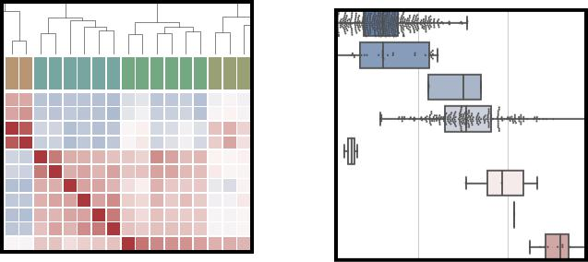

RAUNAK Page 5
Project Report

2 . TRAINING WORK UNDERTAKEN

2.1 COLLECTING DATA FROM KAGGLE

Kaggle is a platform for predictive modelling and analytics competitions in which statisticians and data miners compete to produce the best models for predicting and describing the datasets uploaded by companies and users. This crowd sourcing approach relies on the fact that there are countless strategies that can be applied to any predictive modelling task and it is impossible to know beforehand which technique or analyst will be most effective.

On 8 March 2017, Google announced that they were acquiring Kaggle. They will join the Google Cloud team and continue to be a distinct brand. In January 2018, Booz Allen and Kaggle launched Data Science Bowl, a machine learning competition to analyze cell images and identify nuclei.

2.2 DATA SCIENCE

Data science is an interdisciplinary field that uses scientific methods, processes, algorithms and systems to extract knowledge and insights from data in various forms, both structured and unstructured, similar to data mining.

Data science is a "concept to unify statistics, data analysis, machine learning and their related methods" in order to "understand and analyze actual phenomena" with data. It employs techniques and theories drawn from many fields within the context of mathematics, statistics, information science, and computer science.

Turing award winner Jim Gray imagined data science as a "fourth paradigm" of science

( empirical, theoretical, computational and now data-driven) and asserted that "everything about science is changing because of the impact of information technology" and the data deluge.

When Harvard Business Review called it "The Sexiest Job of the 21st Century"the term

became a buzzword, and is now often applied to business analytics, busines

intelligence, predictive modeling, or any arbitrary use of data, or used as a glamorized term

for statistics. In many cases, earlier approaches and solutions are now simply rebranded as

"data science" to be more attractive, which can cause the term to become "dilute[d] beyond

usefulness." While many university programs now offer a data science degree, there exists no

consensus on a definition or suitable curriculum contents. Because of the current popularity

RAUNAK Page 6
Project Report

of this term, there are many "advocacy efforts" surrounding the field. To its discredit, however, many data science and big data projects fail to deliver useful results, often as a result of poor management and utilization of resources.

So , our project was Heart Disease Prediction , and we used two algorithm here Random forest classifier and Logistic Regression for predicting that in which class the patient will lie i.e whether he will suffer from Heart disease in future or not .

Page 8

Project Report

print('Fraud Cases: {}'.format(len(fraud)))

print('Valid Cases: {}'.format(len(valid)))

0.0017304750013189597

Fraud Cases: 492

Valid Cases: 284315

4 Correlation Matrix

In [9]: corrmt = data.corr() fig =

plt.figure(figsize =

(12,9))

sns.heatmap(corrmt, vmax=.8, square = True)

plt.show()
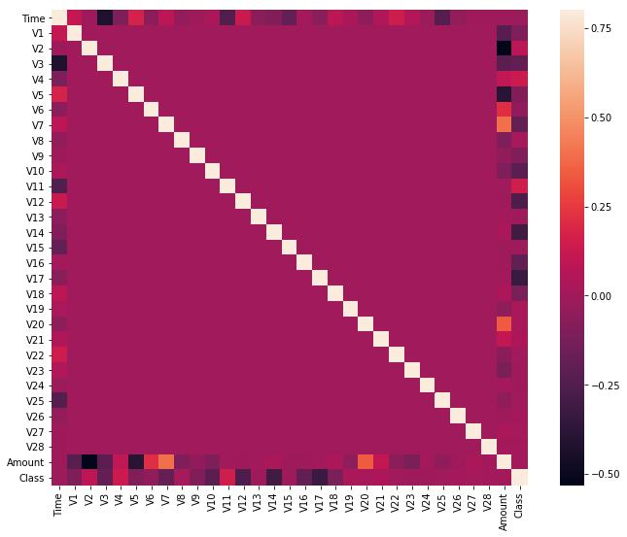

RAUNAK Page 10
Project Report

In [10]: columns = data.columns.tolist() columns = [c for c

in columns if c not in ["Class"]] target = "Class"

- =

da ta[ col

ns]

- =

da ta[ tar ge t]
print(x.shape)

print(y.shape)

(284807, 30)

(284807,)

5 Checking the target classes

In [11]: count_classes = pd.value_counts(data['Class'], sort = True).sort_index()

count_classes.plot(kind = 'bar') plt.title("Fraud class histogram")

plt.xlabel("Class") plt.ylabel("Frequency") plt.show()
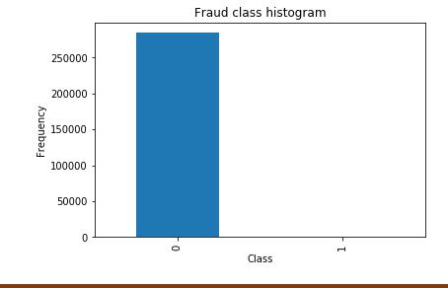

RAUNAK Page 11
Project Report

5.0.1 Clearly the data is totally unbalanced!!

5.0.2 Normalizing Numerical Features

In [12]: # Import sklearn.preprocessing.StandardScaler

from sklearn.preprocessing import MinMaxScaler

- Initialize a scaler, then apply it to the features scaler = MinMaxScaler() # default=(0, 1)

data['normalAmount'] = scaler.fit_transform(data['Amount'].values.reshape(-1, 1))

data = data.drop(['Time','Amount'],axis=1) data.head()

Out[12]: V1 V2 V3 V4 V5 V6 V7 \

- -1.359807 -0.072781 2.536347 1.378155 -0.338321 0.462388 0.239599

- 1.191857 0.266151 0.166480 0.448154 0.060018 -0.082361 -0.078803

- -1.358354 -1.340163 1.773209 0.379780 -0.503198 1.800499 0.791461

- -0.966272 -0.185226 1.792993 -0.863291 -0.010309 1.247203 0.237609

- -1.158233 0.877737 1.548718 0.403034 -0.407193 0.095921 0.592941

 |  | V8 | V9 | V10 ... | V21 | V22 | V
0 | 0.098698 0.363787 0.090794 |  |  | ... | -0.018307 0.277838 -0.110474
1 | 0.085102 | -0.255425 -0.166974 |  | ... | -0.225775 -0.638672 0.101288
2 | 0.247676 | -1.514654 | 0.207643 | ... | 0.247998 0.771679 0.909412
3 | 0.377436 | -1.387024 | -0.054952 | ... | -0.108300 0.005274 -0.190321
4 | -0.270533 0.817739 |  | 0.753074 | ... | -0.009431 0.798278 -0.137458

 | V24 | V25 | V26 | V27 | V28 Class normalAmount
0 | 0.066928 0.128539 -0.189115 |  | 0.133558 -0.021053 |  |  | 0 | 0.005824
1 | -0.339846 0.167170 0.125895 -0.008983 0.014724 |  |  |  |  | 0 | 0.000105
2 | -0.689281 -0.327642 -0.139097 -0.055353 -0.059752 |  |  |  |  | 0 | 0.014739
3 | -1.175575 0.647376 -0.221929 0.062723 0.061458 |  |  |  |  | 0 | 0.004807
4 | 0.141267 -0.206010 0.502292 |  | 0.219422 0.215153 |  |  | 0 | 0.002724

[5 rows x 30 columns]

2. Assigning X and Y. No resampling.

In [13]: #### 3. Resampling.

- = data.iloc[:1001, data.columns != 'Class'] y = data.iloc[:1001, data.columns == 'Class']

In [14]: # Number of data points in the minority class

number_records_fraud = len(data[data.Class == 1])

fraud_indices = np.array(data[data.Class == 1].index)

- Picking the indices of the normal classes normal_indices = data[data.Class == 0].index

RAUNAK Page 12
Project Report

# Out of the indices we picked, randomly select "x" number (number_records_fraud)

random_normal_indices = np.random.choice(normal_indices, number_records_fraud, replace random_normal_indices = np.array(random_normal_indices)

- Appending the 2 indices under_sample_indices =

np.concatenate([fraud_indices,random_normal_indices])

# Under sample dataset

under_sample_data = data.iloc[under_sample_indices,:]

X_undersample = under_sample_data.iloc[:, under_sample_data.columns != 'Class'] y_undersample = under_sample_data.iloc[:, under_sample_data.columns == 'Class']

# Showing ratio

print("Percentage of normal transactions: ", len(under_sample_data[under_sample_data.

print("Percentage of fraud transactions: ", len(under_sample_data[under_sample_data.Cl

print("Total number of transactions in resampled data: ", len(under_sample_data))

Percentage of normal transactions: 0.5

Percentage of fraud transactions: 0.5

Total number of transactions in resampled data: 984

6 Splitting data into train and test set. Cross validation will be used when calculating accuracies.

In [15]: from sklearn.cross_validation import train_test_split

# Whole dataset

X_train, X_test, y_train, y_test = train_test_split(X,y,test_size = 0.3, random_state

print("Number transactions train dataset: ", len(X_train))

print("Number transactions test dataset: ", len(X_test)) print("Total

number of transactions: ", len(X_train)+len(X_test))

# Undersampled dataset

X_train_undersample, X_test_undersample, y_train_undersample, y_test_undersample

- tra

print("") print("Number transactions train dataset: ",

len(X_train_undersample)) print("Number transactions test dataset:

", len(X_test_undersample))

RAUNAK Page 13
Project Report

print("Total number of transactions: ",

len(X_train_undersample)+len(X_test_undersampl

Number transactions train dataset: 700

Number transactions test dataset: 301

Total number of transactions: 1001

Number transactions train dataset: 688

Number transactions test dataset: 296

Total number of transactions: 984

C:\ProgramData\Anaconda3\lib\site-packages\sklearn\cross_validation.py:41:

DeprecationWarning:

"This module will be removed in 0.20.", DeprecationWarning)

In [16]: # importing packages from sklearn.linear_model import LogisticRegression from sklearn.cross_validation import KFold, cross_val_score from sklearn.metrics

import confusion_matrix,precision_recall_curve,auc,roc_auc_score, Create a function to plot a fancy confusion matrix

In [17]: import itertools

def plot_confusion_matrix(cm, classes,

normalize=Fal

se,

title='Confusio

- matrix', cmap=plt.cm. Blues):

"""

This function prints and plots the confusion matrix.

Normalization can be applied by setting `normalize=True`.

- plt.imshow(cm,

interpolation='nearest', cmap=cmap)

plt.title(title) plt.colorbar() tick_marks =

np.arange(len(classes))

plt.xticks(tick_marks, classes,

rotation=0) plt.yticks(tick_marks,

classes)

if normalize:

cm = cm.astype('float') / cm.sum(axis=1)[:, np.newaxis]

RAUNAK Page 14
Project Report

#print("Normalized confusion

matrix") else:

1#print('Confusion matrix, without normalization')

#print(cm)

thresh = cm.max() / 2.

for i, j in itertools.product(range(cm.shape[0]), range(cm.shape[1])):

plt.text(j, i, cm[i, j],

horizontalalignment="center",

color="white" if cm[i, j] > thresh else

"black")

plt.tight_layout()

plt.ylabel('True

label')

plt.xlabel('Predicted

label')

6.0.1 Predictions on test set and plotting confusion matrix

In [18]: # Use this C_parameter to build the final model with the whole training dataset and pr

- dataset lr = LogisticRegression(C = 10, penalty = 'l1') lr.fit(X_train_undersample,y_train_undersample.valu es.ravel()) y_pred_undersample = lr.predict(X_test_undersample.values)

- Compute confusion matrix cnf_matrix =

confusion_matrix(y_test_undersample,y_pred_undersample)

np.set_printoptions(precision=2)

print("Recall metric in the testing dataset: ", cnf_matrix[1,1]/(cnf_matrix[1,0]+cnf_m

- Plot non-normalized confusion matrix class_names = [0,1] plt.figure() plot_confusion_matrix(cn f_matrix

, classes=class_names

- title='Confusion matrix') plt.show()

Recall metric in the testing dataset: 0.918367346939

RAUNAK Page 15
Project Report
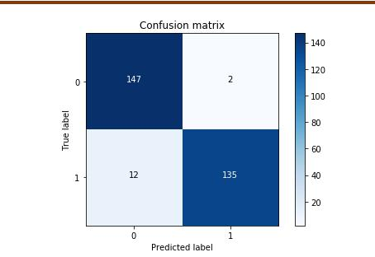

6.1 So, the model is offering an 91.8% recall accuracy on the generalised unseen data

(test set).

RAUNAK Page 16
Project Report

- RESULTS AND DISCUSSION

3.1 RESULT

As we used the logistic regression algorithm, confusion matrix shows the recall
.

accuracy app. 91.8% that is quite good.

We can say that our prediction in most cases will give the accurate result.

3.2 DISCUSSION

Credit card fraud is a wide-ranging term for theft and fraud committed using or involving

a payment card, such as a credit card or debit card, as a fraudulent source of funds in a

transaction.The purpose may be to obtain goods without paying, or to obtain unauthorized

funds from an account. Credit card fraud is also an adjunct to identity theft. According to

the United States Federal Trade Commission, while the rate of identity theft had been holding

steady during the mid 2000s, it increased by 21 percent in 2008. However, credit card

fraud, that crime which most people associate with ID theft, decreased as a percentage of all ID theft complaints for the sixth year in a row.

Although incidences of credit card fraud are limited to about 0.1% of all card transactions, they have resulted in huge financial losses as the fraudulent transactions have been large value transactions. In 1999, out of 12 billion transactions made annually, approximately 10 million—or one out of every 1200 transactions—turned out to be fraudulent. Also, 0.04%

(4 out of every 10,000) of all monthly active accounts were fraudulent. Even with tremendous volume and value increase in credit card transactions since then, these proportions have stayed the same or have decreased due to sophisticated fraud detection and prevention systems. Today's fraud detection systems are designed to prevent one-twelfth of one percent of all transactions processed which still translates into billions of dollars in losses.

In the decade to 2008, general credit card losses have been 7 basis points or lower (i.e. losses of $0.07 or less per $100 of transactions).In 2007, fraud in the United Kingdom was estimated at £535 million.

RAUNAK Page 17
Project Report

4. CONCLUSION AND FUTURE SCOPE

4.1 CONCLUSION

As you can see in the few lines of code above using scikit-learn to build a Logistic Regression prediction model is quite simple. This is truly where the library shines in its ability to easily fit a model and make predictions about an outcome of interest.

When selecting the model for the logistic regression analysis, another important consideration is the model fit. Adding independent variables to a logistic regression model will always increase the amount of variance explained in the log odds (typically expressed as R²). However, adding more and more variables to the model can result in overfitting, which reduces the generalizability of the model beyond the data on which the model is fit.

4.2 FUTURE SCOPE

We designed a system to detect fraud in Credit Card transactions. This system

is capable of providing most of the essential features required to detect fraudulent and legitimate transactions. As technology changes, it becomes difficult to track the behavior and pattern of fraudulent transactions. We have just detected the fraudulent activity but we have not prevented. Preventing known and unknown fraud in real time is not easy but it is feasible. The proposed architecture is basically designed to detect credit card fraud in online payments, and emphasis is made to provide a fraud prevention system to verify a transaction as fraudulent or legitimate. For implementation purposes it is assumed that issuer and acquirer bank is connected to each other. If this system is to be implemented in real time scenario then exchange of best practices and raising consumer awareness among people can be very helpful in reducing the losses caused by fraudulent transactions. Further enhancement can be done by making this system

RAUNAK Page 18
Project Report

5. REFERENCES

https://www.python.org/

https://anaconda.org/anaconda/python

http://www.numpy.org/

https://matplotlib.org/

http://scikit-learn.org/

https://pandas.pydata.org/

https://pandas.pydata.org/

https://ipython.org/

RAUNAK Page 19

